Safe system of work – Form SSW
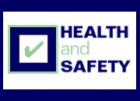
Taking into account the risk assessment already undertaken, outline how the task/method is to be undertaken in a safe manner including specific risk controls, emergency and waste procedures:

Verification by users
Sign below to indicate you have read and understood the safe system of work.
Signature: | Date:

